Git summary – basic knowledge

<https://www.youtube.com/watch?v=S2z9DjFZMoI>

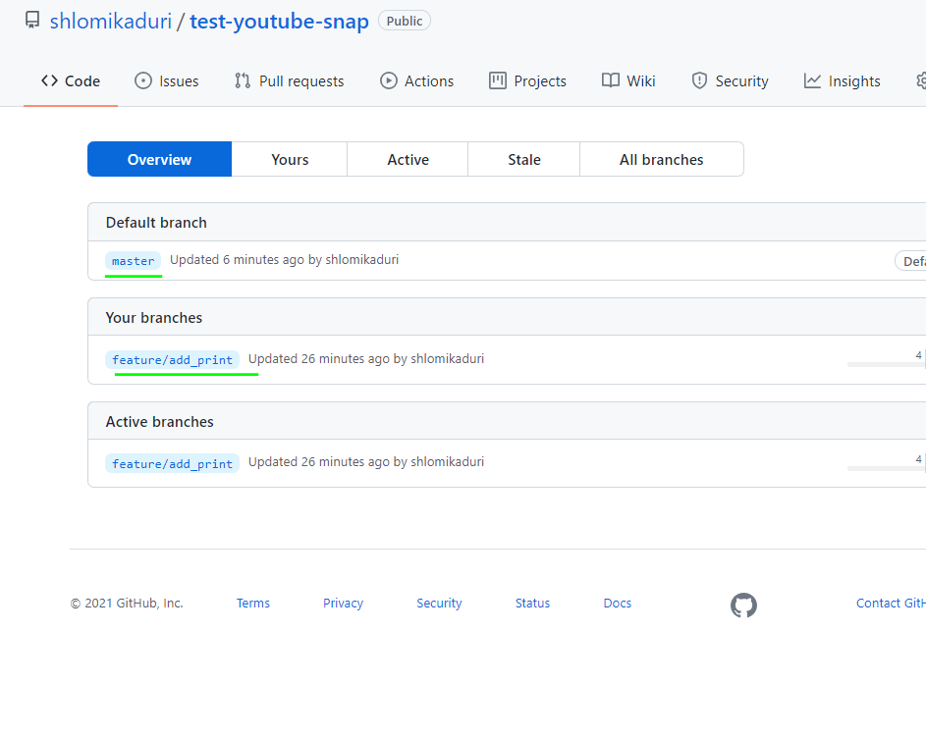

RECOMMEND TO WORK WITH CODE STUDIO

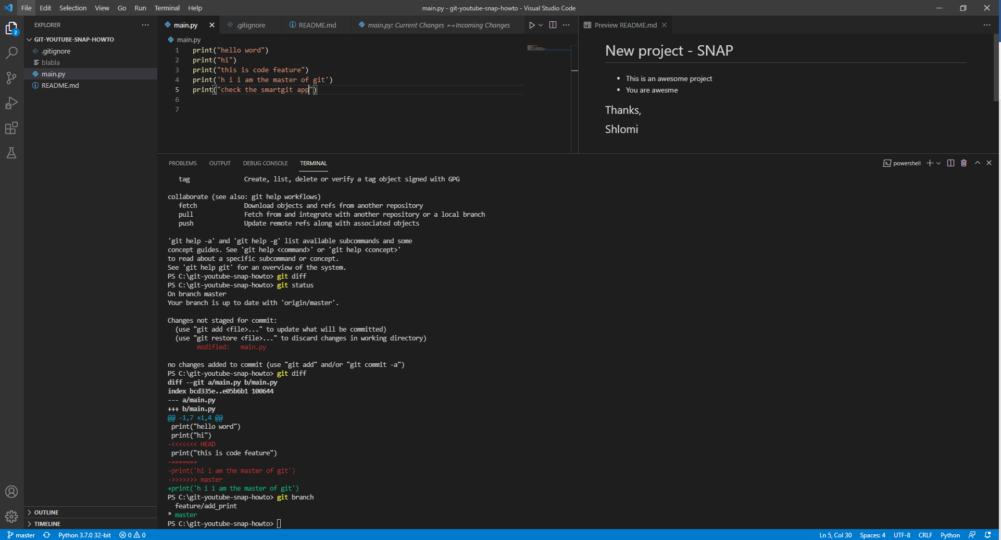

COMMANDS:

git branch – indicate on current branch

git diff – diff between the changes of current modified file

git status – the status, all sync, untracked or modified or added

git push – send the commits to repo

git commit -m "my comment" – create the commit

git add .\README.md – readme file for github readme

git pull – pull the last state from repo

git merge feature/add_print – do merge to current branch with add_print branch

git checkout master – jump to master branch

git checkout feature/add_print - jump to feature/add_print branch

git add .\.gitignore – this file will include list of files that git will ignore them

git log – log of commits

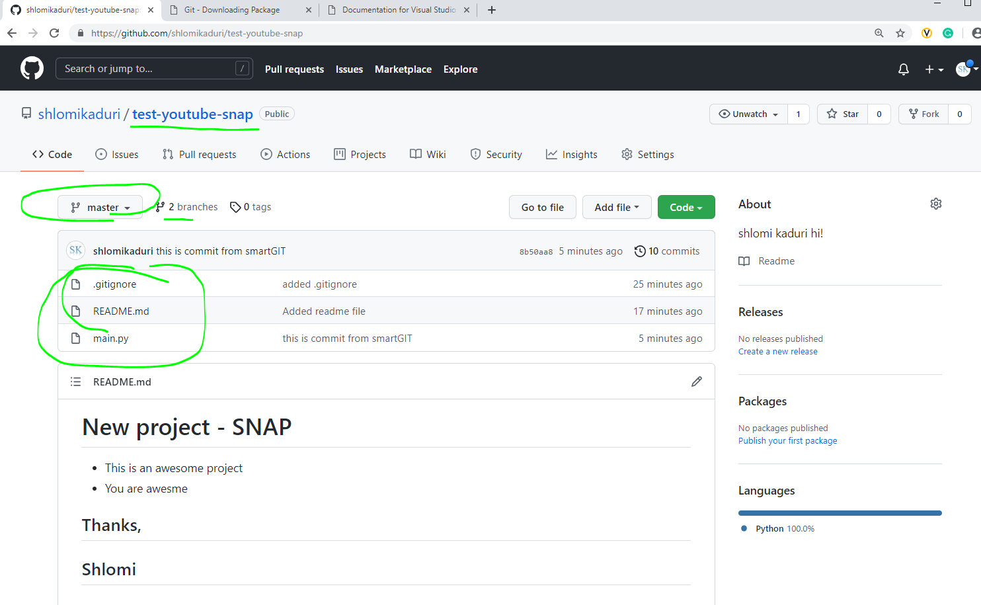

SmartGIT

